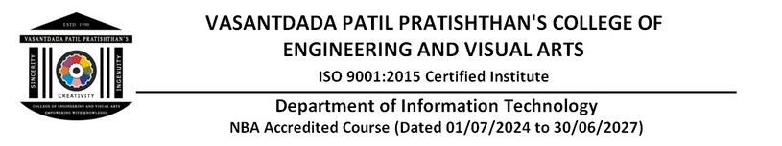

EXPERIMENT - 10

# Aim:

To understand AWS Lambda, its workflow, various functions and create your first Lambda functions using Python / Java / Node js.

# Theory:

## AWS Lambda:

AWS Lambda is a serverless compute service provided by Amazon Web Services (AWS). It allows developers to run code in response to events without provisioning or managing servers. This event-driven, serverless Function as a Service (FaaS) enables rapid and cost-effective modern applications development.

Lambda runs your code on a high-availability compute infrastructure and performs all of the administration of the compute resources, including server and operating system maintenance, capacity provisioning and automatic scaling, and logging. With Lambda, all you need to do is supply your code in one of the language runtimes that Lambda supports.

You organize your code into Lambda functions. The Lambda service runs your function only when needed and scales automatically. You only pay for the compute time that you consume— there is no charge when your code is not running.

## Workflow:

* Function: Your code that Lambda runs
* Event Source: AWS service or custom application that triggers your function
* Trigger: Association between an event source and a Lambda function
* Execution Environment: Secure and isolated runtime environment for your Lambda function

Some examples of various AWS Lambda functions:

1. Image Resizing: A Lambda function can be triggered by an Amazon S3 object upload and resize images to different dimensions, making them suitable for different use cases (e.g., thumbnails, banners).
2. Real-time Data Processing: Lambda functions can be used to process real-time data from IoT devices, such as sensor readings, and trigger actions like sending notifications or updating databases.
3. API Gateway Integration: Lambda functions can be used as the backend for API Gateway, handling API requests and responses, and integrating with other AWS services like DynamoDB or S3.
4. Chatbot or Virtual Assistant: A Lambda function can be triggered by voice or text input and respond with relevant information or actions, integrating with services like Amazon Lex or Amazon Comprehend.
5. Email Processing: Lambda functions can be used to process and analyze email attachments, such as extracting metadata or sending notifications to team members.
6. Log Processing: Lambda functions can be triggered by Amazon CloudWatch Logs and process log data, such as aggregating metrics, detecting anomalies, or sending alerts.
7. Webhook Processing: Lambda functions can be used to process webhooks from third-party services, such as payment gateways or social media platforms, and trigger actions in your application.

STEPS:

1. Sign in to the AWS Management Console, and search for Aws lambda service.

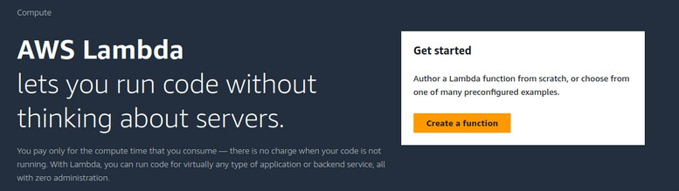

1. Click create a function

Enter the details as given below. → Create

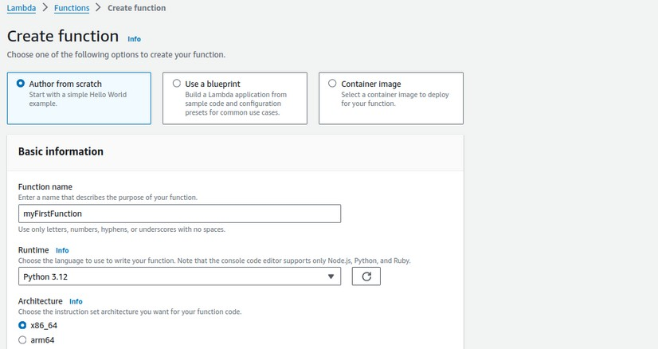

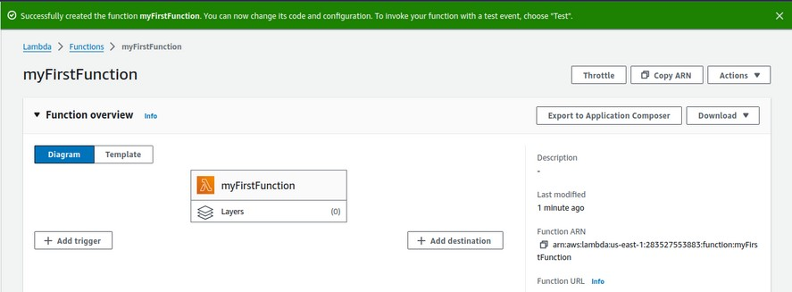

Scroll down to code section,

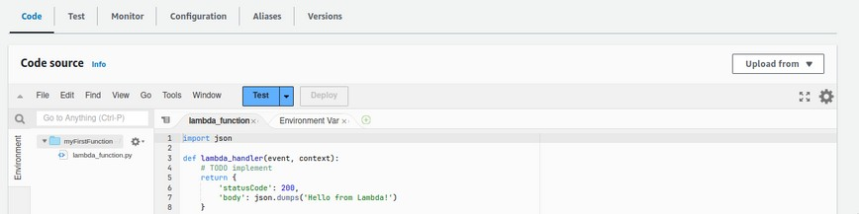

Now change the default code with this:

import json

def lambda_handler(event, context):

print("Received event: " + json.dumps(event, indent=2)) message = 'Hello from Lambda!'

return {

'statusCode': 200,

'body': json.dumps(message)

}

Then, click on deploy, After it is deployed click on “Test”

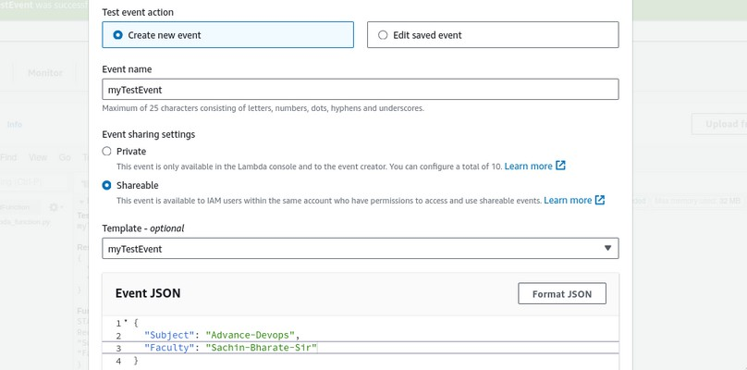

Give name to event, You can change event json data accordingly, then click save. Then again click on test and you will see the output of it.

Note: You can create multiple events for testing purpose.

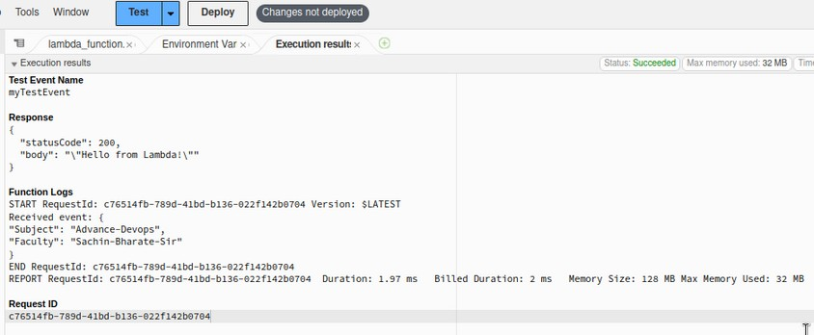

The output contains that json and it is exact output of our code.

# Conclusion: Thus, we have successfully understood AWS Lambda, its workflow,

## various functions and created our first Lambda functions using Python / Java / Node js.